Mound Builder Archaeology Martial Culture Evaluation
The following materials were recovered from burial mounds in Illinois and are currently on display in the Field Museum in Chicago. Examine them and draw conclusions about their purpose, significance, and what they can tell us about Moundbuilder material culture.

Origin of Materials Found at Numerous Moundbuilder Sites

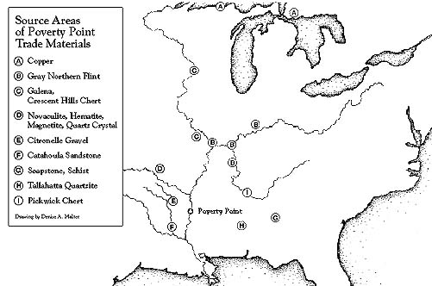

Artifact 1:
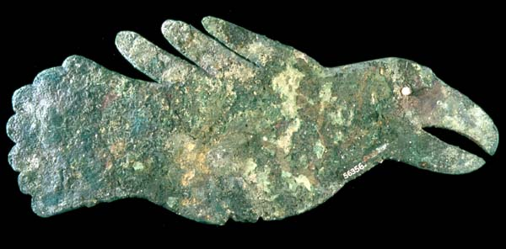
Bird Effigy. This figure was made of copper imported from the Lake Superior region 600 miles away. A river pearl was used as the eye of the bird. This object and the others in this gallery are from Ross County, Ohio and date from A.D. 1-400. The Field Museum (#56356, neg. A110028c)
_____________________________________________________________________________________________________________________________________________________________________________________________________________________

Artifact 2:
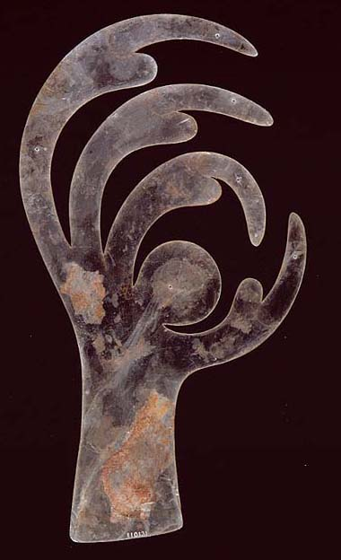
Bird Claw Effigy. Just under 12 inches long, this effigy was cut out of a costly sheet of mica. Mica was obtained from the Appalachian Mountains through direct trade or through exchange with trading partners. Mica work, like copper work, was a highly skilled task The Field Museum (neg. A110016c, #110131)
_____________________________________________________________________________________________________________________________________________________________________________________________________________________

Artifact 3:
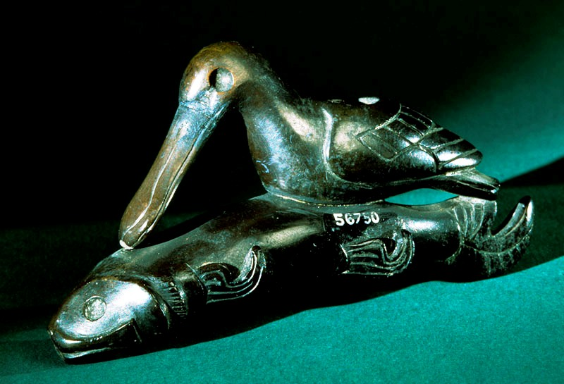
Bird and Fish Effigy Pipe. This small pipe was carved from steatite, a type of stone. The Field Museum (neg. A110058c, #56750)
_____________________________________________________________________________________________________________________________________________________________________________________________________________________

Artifact 4:
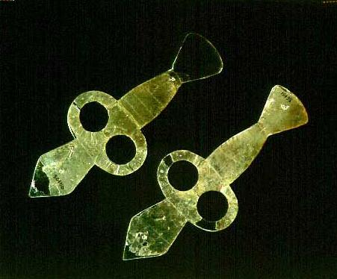
Atlatl Effigy. These 6 inch long mica cutouts represent an atlatl, which was a special spear-throwing stick with a hook used to propel the spear through the air. The atlatl gave the hunter more power and distance. The Field Museum (neg. A110078c, #56451 and 56150)
_____________________________________________________________________________________________________________________________________________________________________________________________________________________

Artifact 5:
: 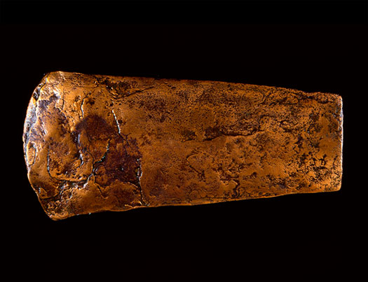
Copper Celt Point. This is an 8 inch long ceremonial axe (celt) Stone axes were used for ordinary household tasks. The Field Museum (neg. A110041c, #56018)
_____________________________________________________________________________________________________________________________________________________________________________________________________________________

Artifact 6:
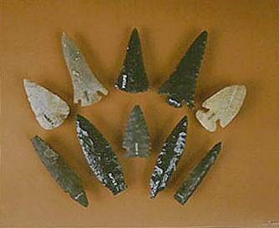
Obsidian Points. Ross County, OH. AD 1-400. Obsidian came from far west in the Rocky Mountains. These stone points often were left as offerings, arranged in patterns, probably by groups of kinspeople or members of a religious society. The Field Museum (neg. A110019c, #56016, 56052, 56086, 56381, 56773, 56774, 56775, 56780)
_____________________________________________________________________________________________________________________________________________________________________________________________________________________

Artifact 7:
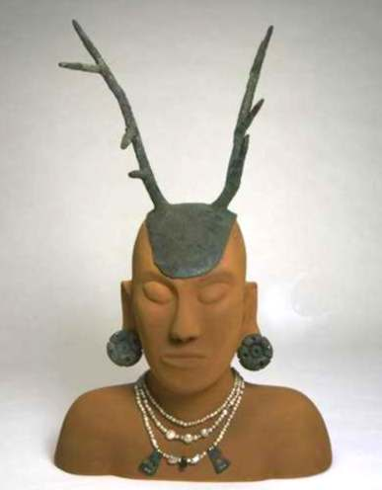
Copper Headdress, Ear Spools, Pearls. The headdress, ear spools, and pearl jewelry were worn by leaders. The copper work took great skill and the materials were costly. The headdress took the form of deer antlers. It was made of wood and covered in copper. The Field Museum (neg. A110046c, #56080, 56091, 56114, 56128, 56200, 56201, 56371, 56751)
_____________________________________________________________________________________________________________________________________________________________________________________________________________________

